Experiment – 6 Parseval's Relation and Harmonic Spectrum Analysis
- To verify Parseval’s relation for continuous-time periodic signals and analyze the relationship between time-domain and frequency-domain power
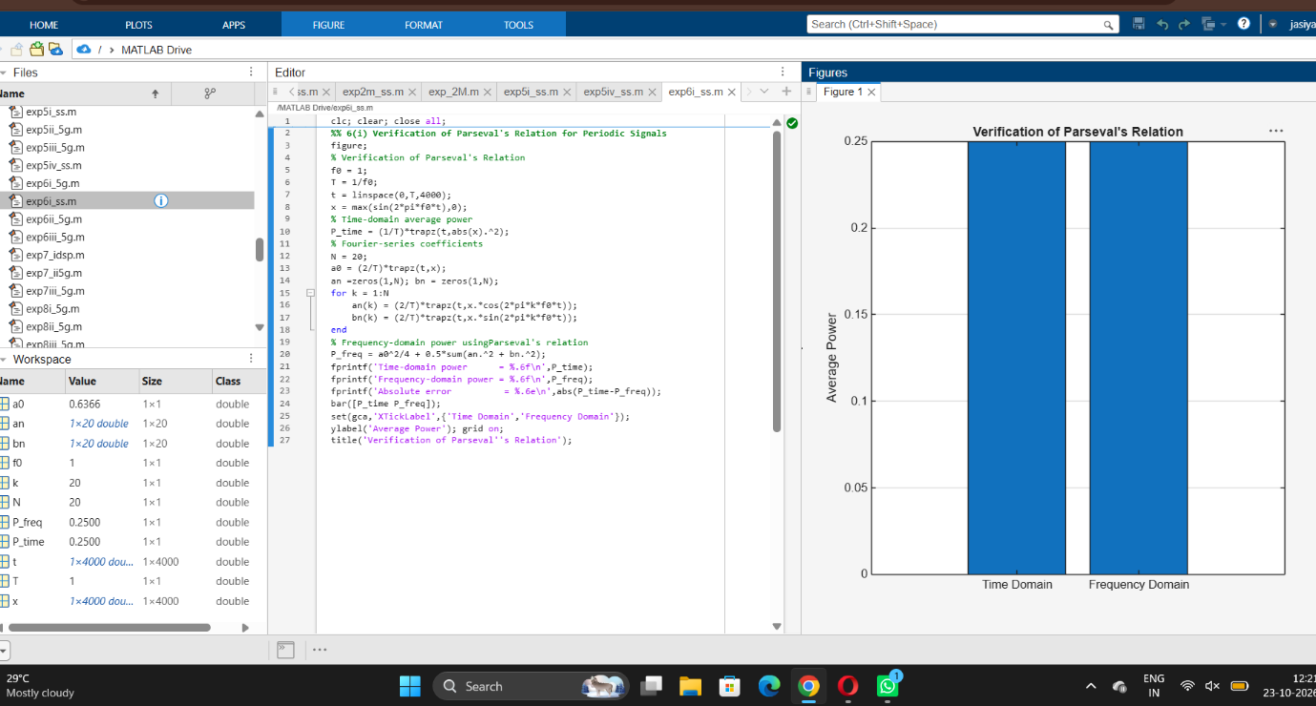
iv) To compare the total power obtained in the time domain with the harmonic power distribution in the frequency domain
